**Criteria 2- Teaching- Learning and Evaluation (350) Key Indicator- 2.1. Student Enrolment and Profile (40)**

|  |  |  |
| --- | --- | --- |
| **Metric** |  | **Weightage** |

|  |  |  |
| --- | --- | --- |
| **No.** |  |  |
| **2.1.1.**  **QnM** | ***Enrolment percentage***   * + - 1. Number of students admitted year wise during last five years       2. Number of sanctioned seats year wise during last five years   𝑃𝑒𝑟𝑐𝑒𝑛𝑡𝑎𝑔𝑒 =  Total number of students admitted  during last five years × 100 Total number of sanctioned seats  during last five years  **File Description (Upload)**   * + - * + Institutional data in the prescribed format (template merged with 2.1.2)         + Upload supporting document | **20** |

Students list year wise 2018-2019 , 2019-2020, 2020-2021, 2021-2022, 2022-2023 branch wise to be attached . Fill the table as per DVV

|  |  |
| --- | --- |
| **2.1.2**  **QnM** | ***Percentage of seats filled against seats reserved for various categories (SC, ST, OBC, etc. as per applicable reservation policy) during the last five years***  ***(Exclusive of supernumerary seats)***   * + - 1. Number of actual students admitted from the reserved categories year wise during last five years       2. Number of seats earmarked for reserved category as per GOI/ State Govt rule year wise during the last five years   𝑃𝑒𝑟𝑐𝑒𝑛𝑡𝑎𝑔𝑒 =  Total number of actual students admitted from the  reserved categories during last five years × 100 Total number of seats earmarked for reserved category  as per GOI/State Govt ruleduring last five years  **File Description (Upload)**   * + - * + Institutional data in the prescribed format (template merged with 2.1.1)         + Upload supporting document |

Fill the table as per DVV and provide list of PIOS (yearwise)

Their certificate of 10th and 12th to be attached ( for other states, other nationals all to be considered if applicable)

|  |  |  |
| --- | --- | --- |
| **Metric**  **No.** |  | **Weightage** |
| **2.2.1.**  **QnM** | ***Student – Full time Teacher Ratio***  ***(Data for the latest completed academic year)***  Formula: Students: Full time teacher | **40** |

It should be provided for the current academic year as per SOP.

List of faculty to be provided in the standard format.

|  |  |  |
| --- | --- | --- |
| **Metric No.** |  | **Weightage** |
| **2.3.1.**  **QlM** | ***Student centric methods, such as experiential learning, participative learning and problem solving methodologies are used for enhancing learning experiences using ICT tools***  Write description in a maximum of 500 words  ***File Description:***   * Upload Additional information * Provide Link for Additional information | **40** |

Student centric methods, experiential learning, flipped classroom techniques etc to be attached.

* Bridge courses [ Circulars for the course to inform students)

For bridge courses

1. Syllabus of the bridge course
2. Time table
3. Circular

|  |  |  |  |  |
| --- | --- | --- | --- | --- |
| S.No | Name of the bridge Course | No of classes conducted | Semester | attendance |
|  |  |  |  |  |
|  |  |  |  |  |
|  |  |  |  |  |

* Remedial Classes [ Time Table of classes after Mid Term 1]

|  |  |  |  |  |
| --- | --- | --- | --- | --- |
|  |  |  |  |  |
|  |  |  |  |  |
|  |  |  |  |  |
| Sno | Name Of The Subject | No Of Classes Conducted | No Of Student Present | Attendance Sheet |
|  |  |  |  |  |
|  |  |  |  |  |

* Reinforcement Classes [ Time Table of classes after semester results ]

|  |  |  |  |  |
| --- | --- | --- | --- | --- |
|  |  |  |  |  |
|  |  |  |  |  |
|  |  |  |  |  |
| SNo | Name Of The Subject | No Of Classes Conducted | No Of Student Present | Attendance Sheet |
|  |  |  |  |  |
|  |  |  |  |  |

* Other Student Centric Methods in the text.

Add the competitions

Add the students seminars

Add the students workshops

Year 1

|  |  |  |
| --- | --- | --- |
| S. No | Name of the event | Number of students participated |
|  |  |  |

Provide data i9n thew above table format for the year2, year 3, year 4 and year 5.

|  |  |  |
| --- | --- | --- |
| **Metric No.** |  | **Weightage** |
| **2.4.1.**  **QnM** | ***Percentage of full-time teachers against sanctioned posts during the last five years***   * + - 1. Number of Sanctioned posts / required positions for teaching staff/ full time teachers year wise during the last five years:   𝑃𝑒𝑟𝑐𝑒𝑛𝑡𝑎𝑔𝑒 =  Total number of full time  teachers year wise during the last five years × 100 Total number of Sanctioned posts/required positions  for full time teachers  **File Description (Upload)**   * + - * + Upload supporting document | **15** |

Fill data as per DVV

Supporting documents

* Appointment orders for the latest year ( 2022- 2023)

|  |  |  |
| --- | --- | --- |
| **2.4.2.**  **QnM** | ***Percentage of full time teachers with NET/SET/SLET/ Ph. D./D.Sc. / D.Litt. during the last five years (consider only highest degree for count)***  2.4.2.1. Number of full time teachers with ***NET/SET/SLET/Ph. D. / D.Sc. / D.Litt.*** year wise during the last five years  𝑃𝑒𝑟𝑐𝑒𝑛𝑡𝑎𝑔𝑒 = | **25** |

|  |  |  |
| --- | --- | --- |
|  | Total number of full time teachers  with such qualifications during last five years × 100 Total number of full time  teachers year wise during last five years  **File Description (Upload)**   * Institutional data in the prescribed format (template merged with Extended profile 2.1) * Upload supporting document |  |

PhD certificates /NET/SET/SLET etc to be attached.

|  |  |  |
| --- | --- | --- |
| **Metric**  **No.** |  | **Weightage** |
| **2.5.1.**  **QlM** | ***Mechanism of internal/ external assessment is transparent and the grievance redressal system is time- bound and efficient***  Write description in a maximum of 500 words  ***File Description:***   * Upload Additional information * Provide Link for Additional information | **40** |

* Grievances

|  |  |  |  |  |
| --- | --- | --- | --- | --- |
| SNO | Name of the students | Subject | Semester | Type of Grievance |
|  |  |  |  |  |
|  |  |  |  |  |
|  |  |  |  |  |
|  |  |  |  |  |

* Type of grievance can be

Revaluation

Admit Card issue

Re-Totaling

Out of Syllabus ( A sample letter from students must be there which was sent to university)

|  |  |  |
| --- | --- | --- |
| **Metric**  **No.** |  | **Weightage** |
| **2.6.1.**  **QlM** | ***Programme Outcomes (POs) and Course Outcomes (COs) for all Programmes offered by the institution are stated and displayed on website and attainment of POs and COs are evaluated***  Write description in a maximum of 500 words  ***File Description:***   * Upload Additional information * Provide Link for Additional information | **25** |

PO of Each programs

Co of all the courses program wise

Co-PO matrix

Attainment calculations for at least three courses.

|  |  |  |
| --- | --- | --- |
| **2.6.2**  **QlM** | ***Attainment of POs and COs are evaluated.***  Explain with evidence in a maximum of 500 words  ***File Description:***   * Upload Additional information * Provide Link for Additional information | **20** |

* Results analysis sheets of the five years with summary sheet as covering letter must be prepared.

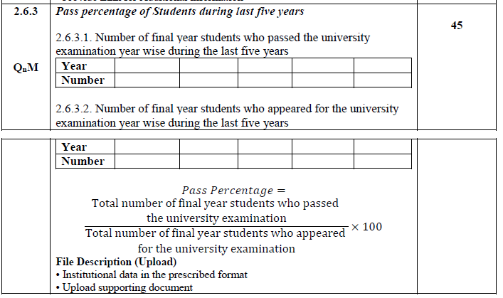

Summary sheet providing details of above calculation with data given in 2.6.2

|  |  |  |
| --- | --- | --- |
| **2.7.1.**  **QnM** | ***Online student satisfaction survey regarding to teaching learning process.***  ***(Online survey to be conducted)***  **File Description:**   * Upload database of all students on roll (Data Template) | **60** |

Fill details as per DVV.